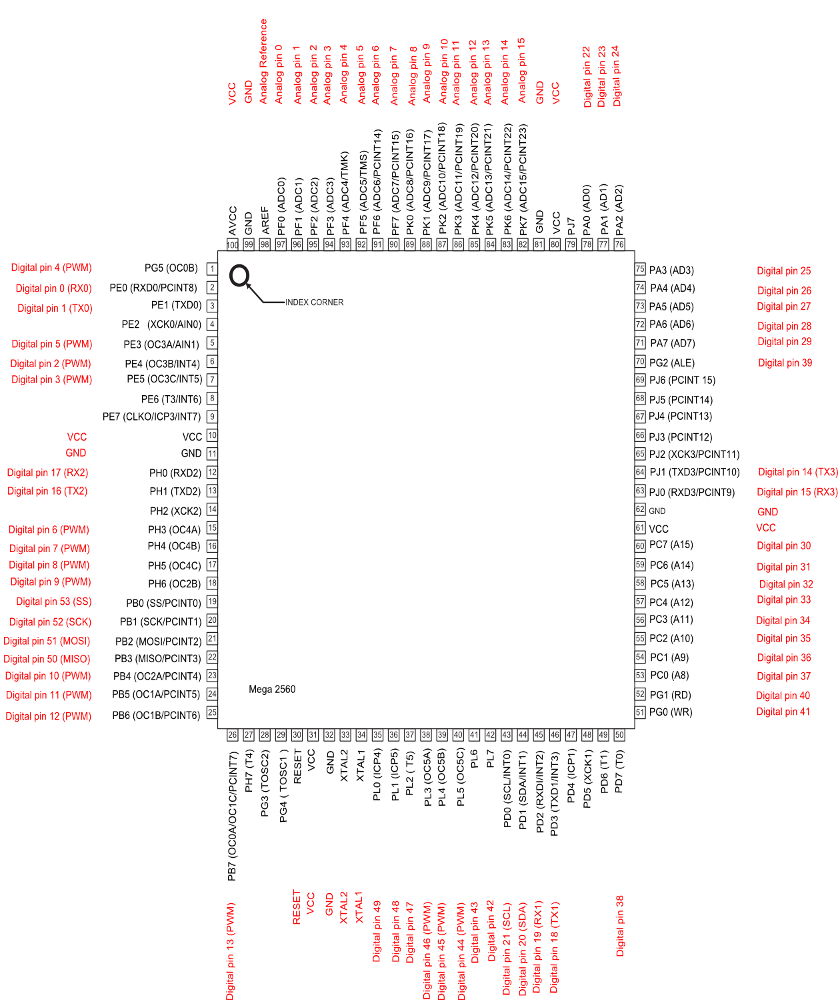

**Arduino Mega 2560 PIN mapping table**

|  |  |  |
| --- | --- | --- |
| **Pin Number** | **Pin Name** | **Mapped Pin Name** |
| 1 | PG5 ( OC0B ) | Digital pin 4 (PWM) |
| 2 | PE0 ( RXD0/PCINT8 ) | Digital pin 0 (RX0) |
| 3 | PE1 ( TXD0 ) | Digital pin 1 (TX0) |
| 4 | PE2 ( XCK0/AIN0 ) |  |
| 5 | PE3 ( OC3A/AIN1 ) | Digital pin 5 (PWM) |
| 6 | PE4 ( OC3B/INT4 ) | Digital pin 2 (PWM) |
| 7 | PE5 ( OC3C/INT5 ) | Digital pin 3 (PWM) |
| 8 | PE6 ( T3/INT6 ) |  |
| 9 | PE7 ( CLKO/ICP3/INT7 ) |  |
| 10 | VCC | VCC |
| 11 | GND | GND |
| 12 | PH0 ( RXD2 ) | Digital pin 17 (RX2) |
| 13 | PH1 ( TXD2 ) | Digital pin 16 (TX2) |
| 14 | PH2 ( XCK2 ) |  |
| 15 | PH3 ( OC4A ) | Digital pin 6 (PWM) |
| 16 | PH4 ( OC4B ) | Digital pin 7 (PWM) |
| 17 | PH5 ( OC4C ) | Digital pin 8 (PWM) |
| 18 | PH6 ( OC2B ) | Digital pin 9 (PWM) |
| 19 | PB0 ( SS/PCINT0 ) | Digital pin 53 (SS) |
| 20 | PB1 ( SCK/PCINT1 ) | Digital pin 52 (SCK) |
| 21 | PB2 ( MOSI/PCINT2 ) | Digital pin 51 (MOSI) |
| 22 | PB3 ( MISO/PCINT3 ) | Digital pin 50 (MISO) |
| 23 | PB4 ( OC2A/PCINT4 ) | Digital pin 10 (PWM) |
| 24 | PB5 ( OC1A/PCINT5 ) | Digital pin 11 (PWM) |
| 25 | PB6 ( OC1B/PCINT6 ) | Digital pin 12 (PWM) |
| 26 | PB7 ( OC0A/OC1C/PCINT7 ) | Digital pin 13 (PWM) |
| 27 | PH7 ( T4 ) |  |
| 28 | PG3 ( TOSC2 ) |  |
| 29 | PG4 ( TOSC1 ) |  |
| 30 | RESET | RESET |
| 31 | VCC | VCC |
| 32 | GND | GND |
| 33 | XTAL2 | XTAL2 |
| 34 | XTAL1 | XTAL1 |
| 35 | PL0 ( ICP4 ) | Digital pin 49 |
| 36 | PL1 ( ICP5 ) | Digital pin 48 |
| 37 | PL2 ( T5 ) | Digital pin 47 |
| 38 | PL3 ( OC5A ) | Digital pin 46 (PWM) |
| 39 | PL4 ( OC5B ) | Digital pin 45 (PWM) |
| 40 | PL5 ( OC5C ) | Digital pin 44 (PWM) |
| 41 | PL6 | Digital pin 43 |
| 42 | PL7 | Digital pin 42 |
| 43 | PD0 ( SCL/INT0 ) | Digital pin 21 (SCL) |
| 44 | PD1 ( SDA/INT1 ) | Digital pin 20 (SDA) |
| 45 | PD2 ( RXDI/INT2 ) | Digital pin 19 (RX1) |
| 46 | PD3 ( TXD1/INT3 ) | Digital pin 18 (TX1) |
| 47 | PD4 ( ICP1 ) |  |
| 48 | PD5 ( XCK1 ) |  |
| 49 | PD6 ( T1 ) |  |
| 50 | PD7 ( T0 ) | Digital pin 38 |
| 51 | PG0 ( WR ) | Digital pin 41 |
| 52 | PG1 ( RD ) | Digital pin 40 |
| 53 | PC0 ( A8 ) | Digital pin 37 |
| 54 | PC1 ( A9 ) | Digital pin 36 |
| 55 | PC2 ( A10 ) | Digital pin 35 |
| 56 | PC3 ( A11 ) | Digital pin 34 |
| 57 | PC4 ( A12 ) | Digital pin 33 |
| 58 | PC5 ( A13 ) | Digital pin 32 |
| 59 | PC6 ( A14 ) | Digital pin 31 |
| 60 | PC7 ( A15 ) | Digital pin 30 |
| 61 | VCC | VCC |
| 62 | GND | GND |
| 63 | PJ0 ( RXD3/PCINT9 ) | Digital pin 15 (RX3) |
| 64 | PJ1 ( TXD3/PCINT10 ) | Digital pin 14 (TX3) |
| 65 | PJ2 ( XCK3/PCINT11 ) |  |
| 66 | PJ3 ( PCINT12 ) |  |
| 67 | PJ4 ( PCINT13 ) |  |
| 68 | PJ5 ( PCINT14 ) |  |
| 69 | PJ6 ( PCINT 15 ) |  |
| 70 | PG2 ( ALE ) | Digital pin 39 |
| 71 | PA7 ( AD7 ) | Digital pin 29 |
| 72 | PA6 ( AD6 ) | Digital pin 28 |
| 73 | PA5 ( AD5 ) | Digital pin 27 |
| 74 | PA4 ( AD4 ) | Digital pin 26 |
| 75 | PA3 ( AD3 ) | Digital pin 25 |
| 76 | PA2 ( AD2 ) | Digital pin 24 |
| 77 | PA1 ( AD1 ) | Digital pin 23 |
| 78 | PA0 ( AD0 ) | Digital pin 22 |
| 79 | PJ7 |  |
| 80 | VCC | VCC |
| 81 | GND | GND |
| 82 | PK7 ( ADC15/PCINT23 ) | Analog pin 15 |
| 83 | PK6 ( ADC14/PCINT22 ) | Analog pin 14 |
| 84 | PK5 ( ADC13/PCINT21 ) | Analog pin 13 |
| 85 | PK4 ( ADC12/PCINT20 ) | Analog pin 12 |
| 86 | PK3 ( ADC11/PCINT19 ) | Analog pin 11 |
| 87 | PK2 ( ADC10/PCINT18 ) | Analog pin 10 |
| 88 | PK1 ( ADC9/PCINT17 ) | Analog pin 9 |
| 89 | PK0 ( ADC8/PCINT16 ) | Analog pin 8 |
| 90 | PF7 ( ADC7 ) | Analog pin 7 |
| 91 | PF6 ( ADC6 ) | Analog pin 6 |
| 92 | PF5 ( ADC5/TMS ) | Analog pin 5 |
| 93 | PF4 ( ADC4/TMK ) | Analog pin 4 |
| 94 | PF3 ( ADC3 ) | Analog pin 3 |
| 95 | PF2 ( ADC2 ) | Analog pin 2 |
| 96 | PF1 ( ADC1 ) | Analog pin 1 |
| 97 | PF0 ( ADC0 ) | Analog pin 0 |
| 98 | AREF | Analog Reference |
| 99 | GND | GND |
| 100 | AVCC | VCC |